Background: UFO Sighting

The objective of this assignment is to create a basic HTML web page that contains a table dynamically based upon a dataset of UFO sightings. This web page will allow users to search through the table for specific pieces of information. The goal for this assignment is to use the provided UFO dataset given in a JavaScript object and write a code that would append a table to the web page and then add new rows of data for each UFO sighting.

Level 1: Automatic Table and Date Search

Use a date form in the HTML document and write a JavaScript code that will listen for events and search through the date column to find rows that match user input.

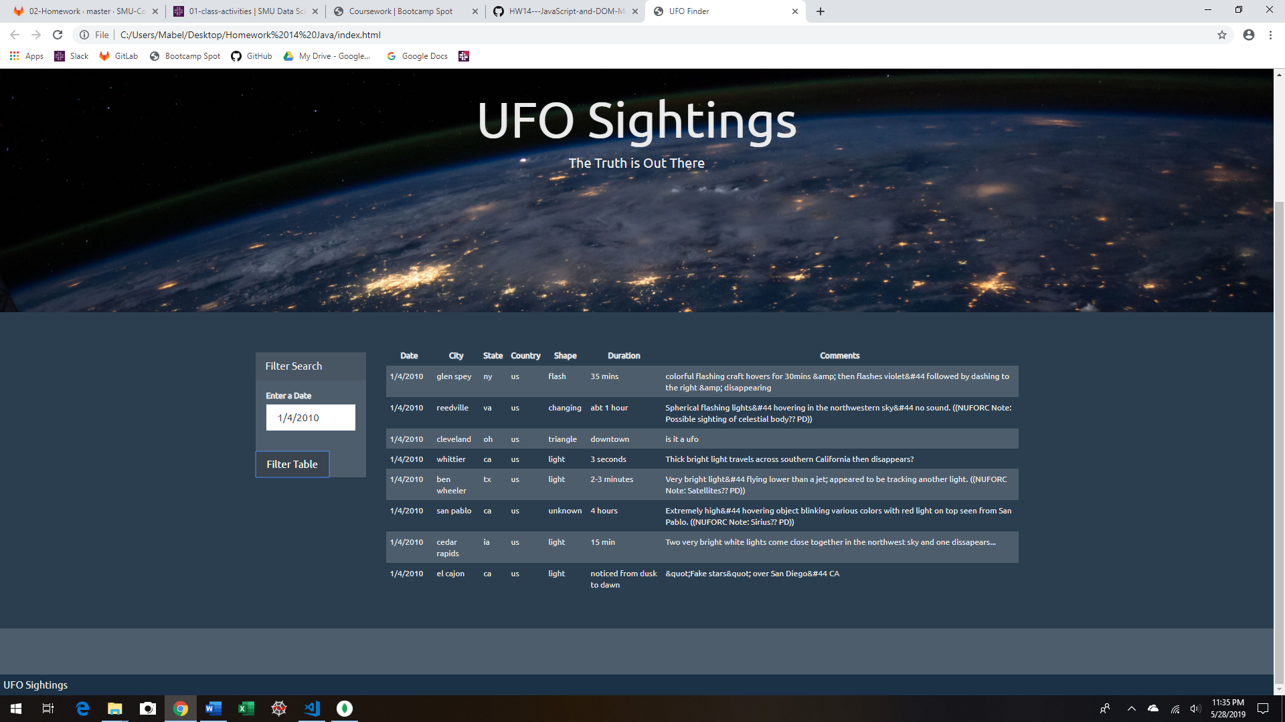

Level 2: Add Multiple Search Categories (Optional)

Conclusions:

The only limitation that I saw was that the date had to follow a certain format. The filter will not work if the date was input as a two-digit month/day and year. Although multiple search filtering input can be added to this web page my limited knowledge and time constraints limited me to only include the date filter form. If additional time becomes available, the next step would be to add filtering criteria based on the table column names.